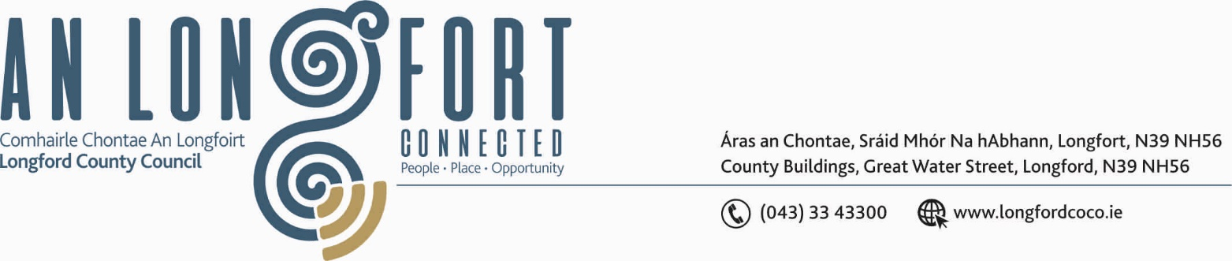

BALLYMAHON MUNICIPAL DISTRICT

20th September 2019.

To: Each Member of Ballymahon Municipal District.

Dear Member,

You are requested to attend Meeting of Ballymahon Municipal District to be held in Ballymahon Community Library, on Thursday, 26th September 2019 at
4.00 p.m. to transact business, as set out on the Agenda hereunder.

Yours sincerely,
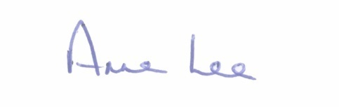

_______________
Anne Lee,
Meetings Administrator.

AGENDA

Prayer before meeting.

1. Confirmation of Minutes of Ballymahon Municipal District Meeting held on the 25th July 2019 - copy enclosed.

2. Matters arising from Minutes.

3. Declaration of Interest by Members.

4. Broadband Connection Points

5. Management Report - enclosed.

6. Consideration of Standing Orders - draft enclosed.

7. Consideration of applications for funding under the 2019 Community Grant Support Scheme - list enclosed.

8. Consideration of the intention to declare roads at Lyneen, Killashee, to be Public Roads - report enclosed.

9. Notices of Motions submitted by Councillors, as listed hereunder –

Councillor Pat O’Toole.

“I call on Longford County Council to prepare a Part 8 planning application from the end of the Ballymahon Infrastructural Plan at the Dean Egan Library/Bridgeways Family Resource Centre to extend out to the Royal Canal at Longford Bridge.

Under the Part 8 a number of long standing issues could be addressed, including the provision of bus parking bays, upgrading of the existing pedestrian crossing, extending the proposed cycle track way under the plan to St. Matthew's School and then onto the Royal Canal to include street lighting.”

Councillor Paul Ross.

“That Longford County Council applies for a Low Cost Safety Scheme to install traffic calming measures and a pedestrian crossing at St Mel’s National School Ardagh to allow children to cross the road safely.”

“That the turn at Furze, Legan be widened in the interest of public safety.”

“That cycle racks be provided for on the Main Street of Ballymahon as part of the Main Street Regeneration.”

10. Correspondence – circulated.
(i) Correspondence dated 20th August 2019 received from the Office of the Minister for Transport, Tourism and Sport regarding funding for footpath repairs.



